Date: 1st December 2025

To whomsoever it may concern
This is to certify that Pranav Kulkarni was employed with Stratveda Technologies Private Limited as a Trainee in the IT development freelancing as Full-Stack Engineer from 21st August 2025 to 31st October 2025.

During this period, he supported the team in research and documentation activities.

Throughout the tenure, he showed a willingness to learn, maintained discipline, and displayed a positive attitude towards assigned tasks.

We appreciate Pranay for his contributions during the training tenure and wish him the very best for their future career.


Signed and delivered on behalf of StratVeda Technologies Pvt. Ltd.
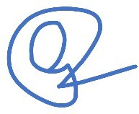

Name: Gurleen Kaur Designation: Co-founder and CFO

